An analytical briefing on content trends, audience preferences, and production dynamics

Abstract

This report explores patterns in Netflix content using crdits, titles and movie_infor data, focusing on popularity, content type, country of origin, and movie characteristics. Findings show that TV shows consistently outperform movies in popularity, with UK and Sweden leading in show performance. Meanwhile, the US and Mexico dominate in film popularity, and India produces the longest movies. These insights offer strategic direction for content investment in future streaming ventures.

# Introduction

With Netflix facing a decline in users and share price, understanding content preferences is critical for new streaming ventures. This analysis examines content popularity, regional trends, and movie characteristics on Netflix. By analyzing shows and movies by country, runtime, and cast structure, we identify patterns in global viewing behavior. The findings aim to inform investor decisions and optimize future content strategies.

# 

# Data

After using the dfSummary() function, we can conclude that the data set is well-organized and clean. The summary output shows no duplicates, very few missing values, and consistent variable structures across over 6,000 entries. These indicators confirm that the data set is reliable and ready for further analysis.

# Results and Analysis

## Average Popularity by Type

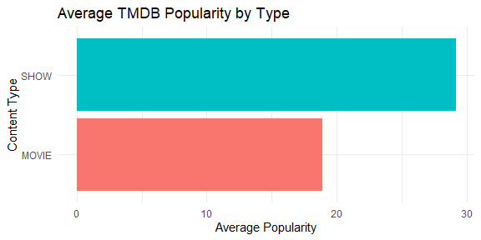

Caption Here

The figure above shows that shows are, on average, more popular than movies based on TMDB popularity scores. This suggests that serialized content drives stronger viewer engagement than standalone films. The trend may be due to factors like binge-watching behavior, narrative depth, and global breakout shows. Given this, Netflix should prioritize investment in high-quality, locally relevant TV shows. Further analysis by country and genre can refine content strategy decisions.

## Popularity by Type and Country

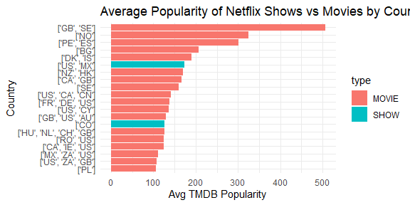

The analysis reveals that television shows originating from the United Kingdom (GB) and Sweden (SE) exhibit the highest average popularity among global audiences. This suggests a strong international appeal and production quality associated with series from these regions. In contrast, the United States (US) and Mexico (MX) lead in terms of movie popularity, indicating their dominant role in global film production. These findings highlight regional strengths in different content formats on Netflix.

# Boxplot: Movie Length and IMDb Score by Country

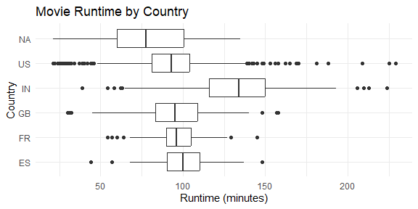

The boxplot shows the distribution of movie runtimes by country, with runtime in minutes on the x-axis and countries on the y-axis. India has the highest median movie runtime (around 130 minutes) and a wide spread, indicating high variability and many long films. The US and GB have moderate runtimes, typically around 90–100 minutes, with fewer extreme outliers. France and Spain tend to produce shorter, more consistent-length movies. The NA category, likely representing unspecified or mixed countries, shows the broadest range of runtimes.

## Balance of actors vs. directors

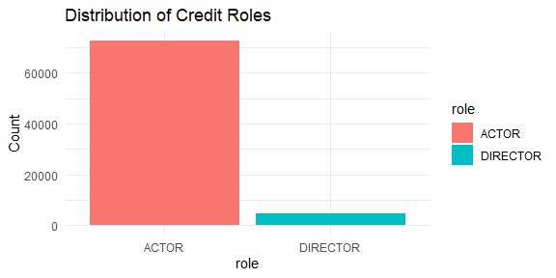 The graph shows that every movie has more actors than directors, with actor bars consistently taller across all entries. This is expected, as most films require multiple characters played by different actors but typically only one or two directors to oversee the production. Directors manage the overall vision, while actors bring individual roles to life. Hence, the nature of filmmaking naturally results in a higher number of actors per movie.

## For interests sakes: most credited actors or actresses

Shah Rukh Khan appears in the highest number of Netflix titles, with 30 credited roles, making him the most prominently featured actor in the data set. This likely reflects both his long-standing dominance in Bollywood and the strong demand for Indian cinema on streaming platforms. His global fan base and consistent involvement in high-profile productions contribute to his visibility. Netflix’s expanding catalog of Indian content further amplifies his presence.

# Conlusion

The analysis shows that serialized TV shows, particularly from the UK and Sweden, drive stronger engagement than movies, suggesting that new platforms should prioritize locally produced high-quality series. In contrast, countries like the US and Mexico lead in movie popularity, reflecting their dominance in global film production. India’s notably long runtimes suggest strong regional storytelling preferences. To succeed, a new streaming service should invest in engaging, binge-worthy TV content while selectively curating movies from dominant production regions.